**Question**:-Create a new Azure SQL DB with the name 'Mission100+Yourname+DOB+DB' inside the resource group 'azurelib'.

## Keep the Sample Db included while creating this Db.

## You need to create a new DB server as well while creating this Database.

## 

## 

## Remark: Ensure you are choosing the Basic tier while making the DB, to have low cost.

Solution:-

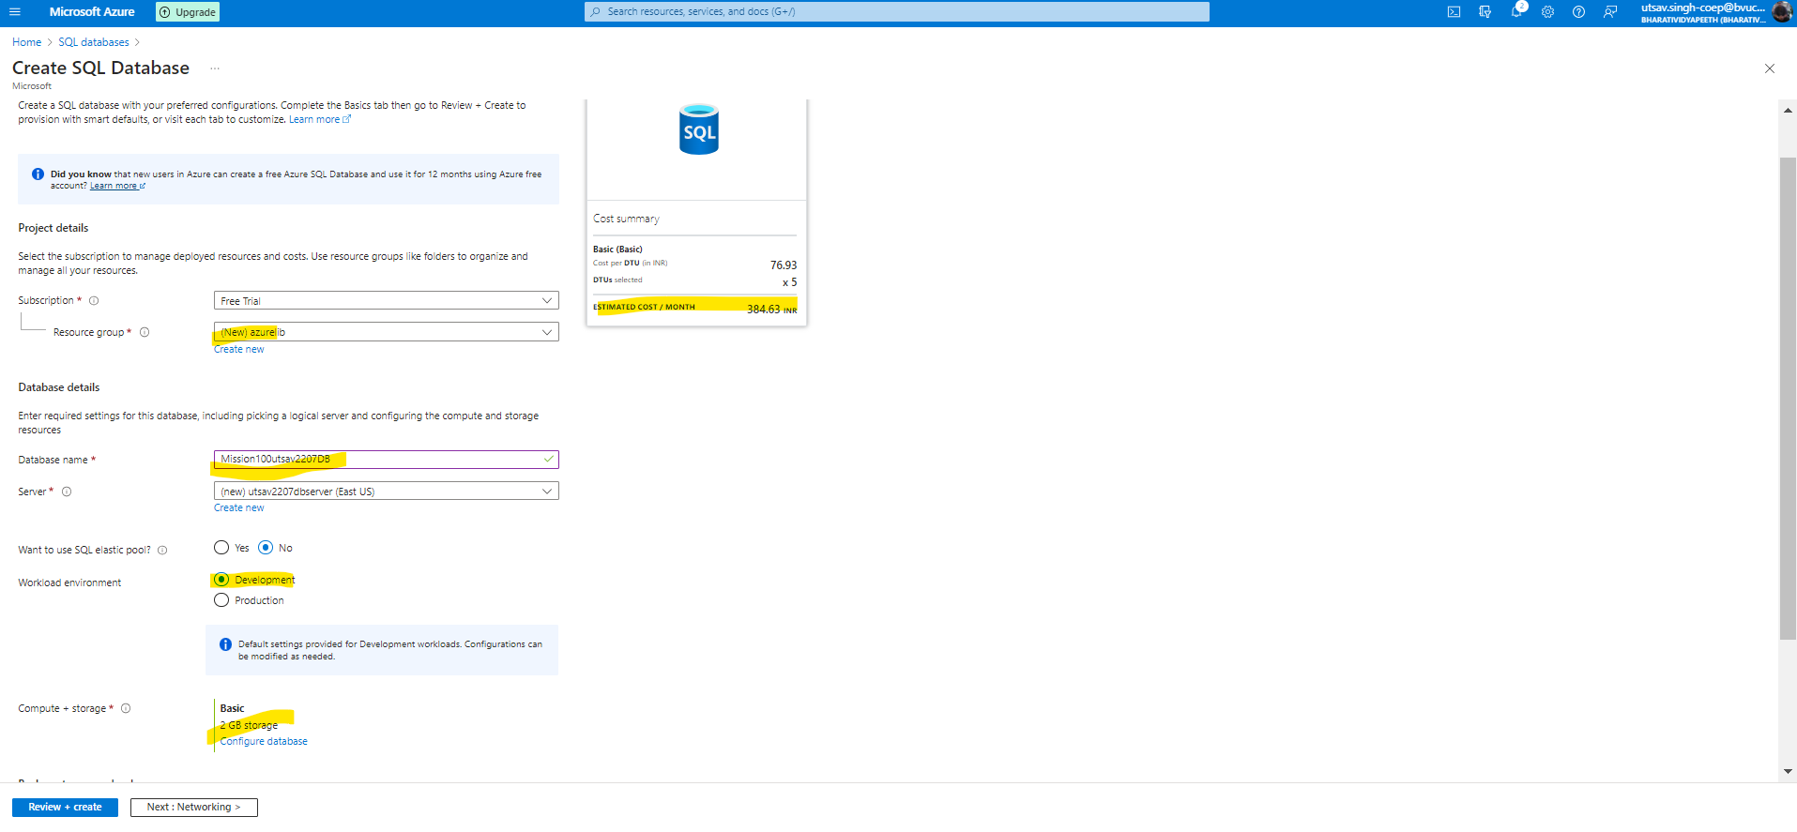

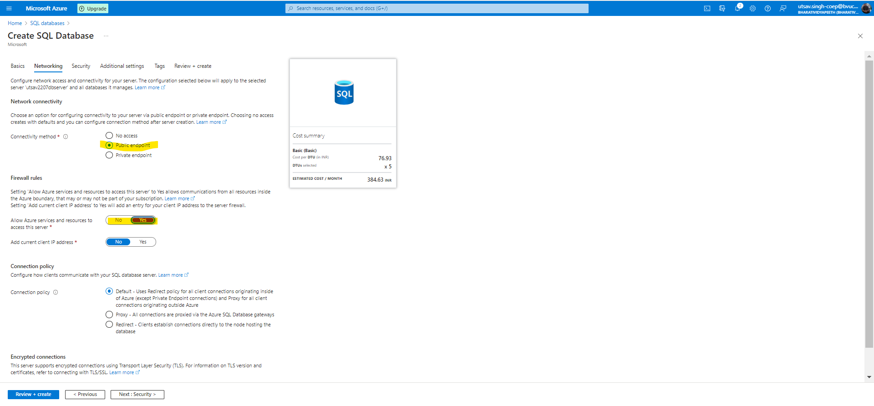

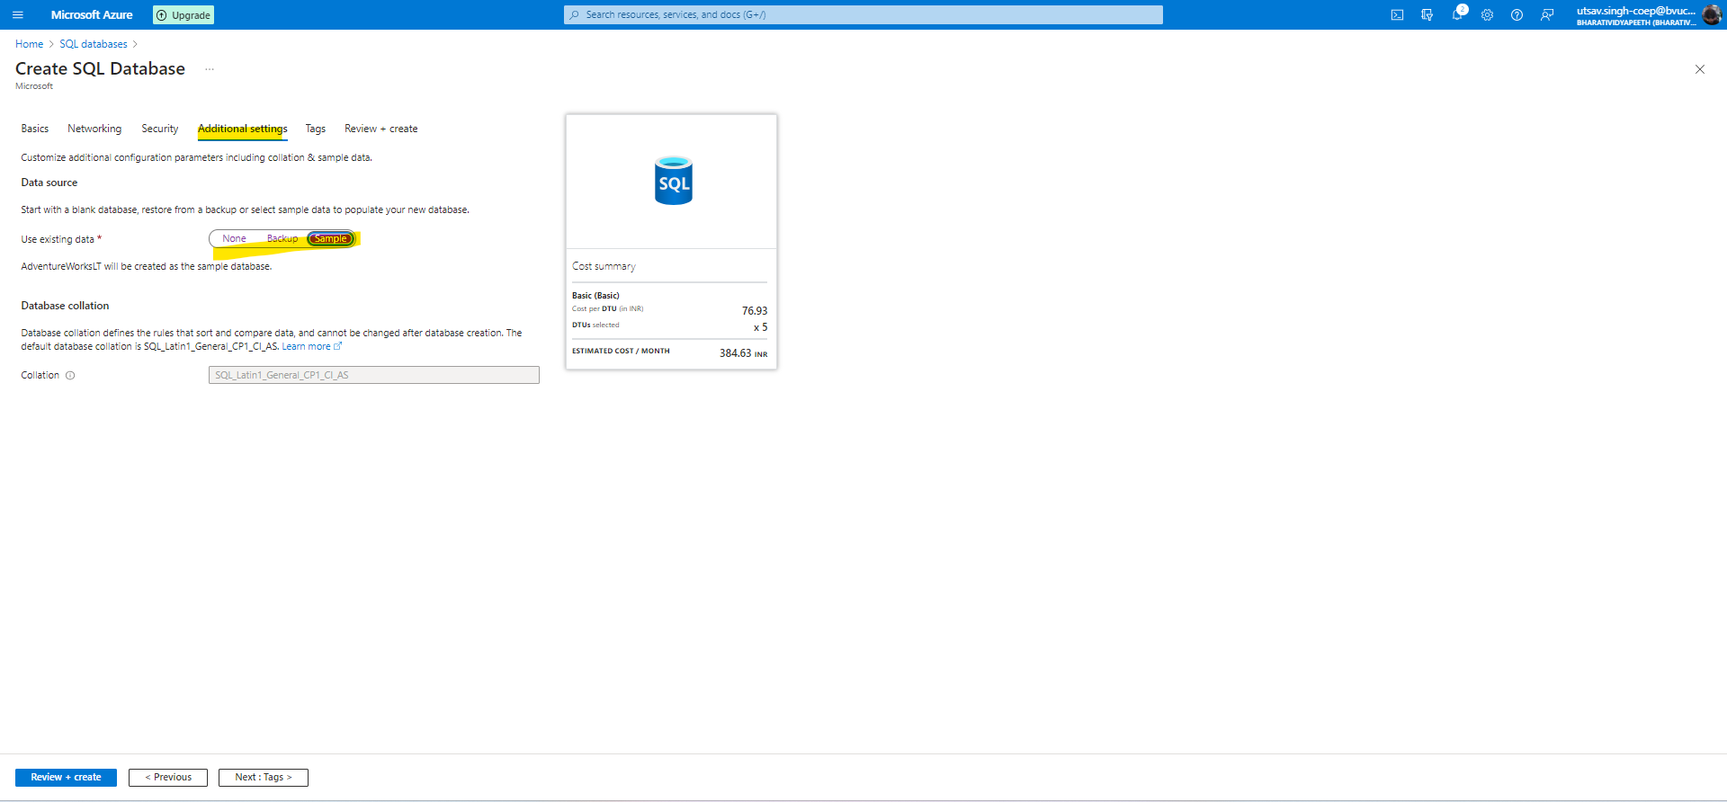

**In rest step keep as it is**

